**Wireless Multicast System with Connection and Connectionless Modes**

Pooja S P  
 K S Institute of Technology  
 Electronics and Communication Engineering Bangalore

poojasp940@gmail.com

*Abstract*— *This paper proposes a novel method of wireless multicast communication with a mixed mode of connection and connectionless orientation. Taking advantage of broadcast characteristics of wireless media and overcoming the independent errors in the transmission, we establish a new algorithm to minimize the transmission time. A state transition of transmission of connection and connectionless mode are described. With random and burst BER for each terminals assumed, the performances are analyzed with computer simulation. It is shown that the total transmission time was much reduced compared with that of the conventional system*.

Keywords——wireless, connection, connectionless, reliable multicast(RM) , ACK, NACK.

1. INTRODUCTION

As the number of computers connected with the network increases explosively, transmitting the copies of the same data to a lot of computers has increased. The method to realize this is multicast. Nowadays multicast is one of the most regarded mechanisms because it reduces the load of a server and makes efficient use of the bandwidth in the network. Reliable Multicast (RM) is a mechanism that makes the multicast reliable, and a lot of Reliable Multicast Protocol has been proposed. This is the protocol to transmit copies of the same data to receivers correctly (error-free), and it offers high reliability for each data frame with error control scheme .RM protocols are classified into ACK-based scheme and NACK-based scheme. The ACK-based protocols offer high reliability, because the sender confirms if the correct frames transmitted to all receivers. However, if ACK is transmitted at a comparatively short cycle, ACK implosion will happen easily. In this paper, a method applying the ACK-based is proposed. Only one receiver of a multicast group responds with ACK or NACK to a multicast data frame reception with connection mode. The other receivers with connectionless mode do not respond at all. They store error frame numbers without requesting retransmission of the error frame, and all of the error frames are retransmitted with the connection mode later. Because the receiver, which can request retransmission anytime, is limited to one and it is fixed until it can completely receive all frames, the NACK collision will never happen. This paper is composed as follows. In section Ⅱ, communication procedure of proposed multicast method and state transition by tree structure are described. In section Ⅲ, performance of the proposed method is evaluated by computer simulation in terms of throughput and transfer time for multicast frames. Section Ⅳ concludes this paper.

Ⅱ. PROPOSED MULTICAST METHOD

We propose a novel method of wireless multicast communication with a mixed mode of connection and connectionless orientation. In this method, a host designates a receiver that communicates with connection mode. And other receivers, while the host transmits data frames to the designated receiver, intercept the frames with connectionless mode and store them if there is no error. After the end of transmission to the designated receiver, the fa ilure frames are retransmitted from the host with connection mode. The collision of feedback is not caused because the number of receiver which returns ACK or NACK of the frame reception remains one during the session. As a result, total transmission time is shortened. The total transmission time means the time until all receivers can receive all data frames completely.

A. Network Model

Network model assumed in this paper is illustrated in Fig.1. A multicast group composed of a source host and some receivers is assumed. The source host transmits the multicast data frames to the group. One of all receivers is designated as a connection mode receiver and the others will be connectionless mode receivers. The condition is that paths from the host to each receiver are independent.

Fig : Network model

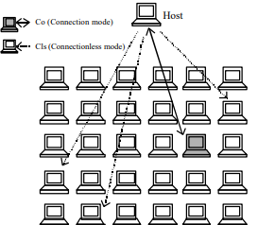

B. COMMUNICATION PROCEDURE

1. The communication procedure is shown below. 1) A receiver communicates with connection mode is selected as a connection mode receiver.
2. The host transmits a multicast frame to all receivers. All receivers receive the frame.
3. ‘Co’ returns ACK or NACK of the frame reception. If the received frame contains some errors, ‘Co’ returns NACK.
4. When the host receives the NACK, it retransmits the multicast frame to all receivers according to SR-ARQ error control scheme.
5. ‘Cls’ merely receive the multicast frame from host without returning NACK even if they received the error frame. Error frames are discarded and the error frame numbers are stored.
6. After ‘Co’ receives all multicast frame completely, the frames which the ‘Cls’ failed to receive

Ⅲ. SYSTEM EVALUATION

The system of the proposed method is evaluated by computer simulation compared with a conventional method.

1. RANDOM ERROR CHANNEL

THROUGHPUT

shows throughput performance when there are 30 receivers. It is assumed that all receivers have the same BER. Throughput is the most important index for the performance evaluation of the system. The receiver, which can return responses for the reception frames, is limited to one. Therefore, the NACK repetition for the same frame can be prevented and the number of responses is decreased. Moreover, because it is not necessary to wait during random time to evade the collision of the responses, wasted time is reduced.

TOTAL TRANSMISSION TIME

The followings describe which receiver will be the most efficient ‘Co’. Fig.5 shows the total transmission time for BER of ‘Co’ when the BERs of all ‘Cls’ are 4 10 - . The total transmission time is time until all receivers can receive completely all multicast frames. In proposed 2, the total transmission time is short, not depending on BER of ‘Co’. In proposed 1, if ‘Co’ has a certain BER, the time will be shortened, though it will not be shortened if ‘Co’ has low BER. Therefore, in proposed 1, it is important which receiver to be taken as ‘Co’. However, in multicast communication environment, there is a possibility that the BER changes dynamically, therefore, this will be not so practicable. In proposed 2, even if which receiver is taken as ‘Co’, the total transmission time is shortened, so it is practicable. Fig.6 shows the total transmission time for BER of ‘Co’ when the BERs of ‘Cls’ are 5 10 - . There is a high possibility that some ‘Cls’ do not need retransmission when the BERs of ‘Cls’ are low, and that all receivers might be able to receive completely all frames during the failure frames of ‘Co’ are being retransmitted. Therefore, there are not so many differences between performances of each method.

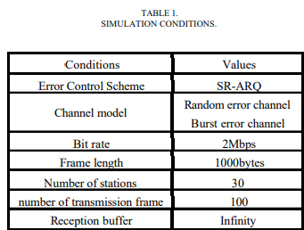

1. BURST ERROR CHANNEL

In random error channel, the system was evaluated. Here, Gilbert channel according to 2-state Markov model is assumed, and the performance of the system for the burst-error is evaluated. Fig.7 shows a state diagram for a 2-state Markov model. In the Bad state (B) errors occur with probability 1 while in the Good state (G) they occur with probability 0 (error-free) as the simplified Gilbert model. In this case, the average frame error rate is (1). The correlation r of two consecutive error frames is (2).[8]-[10] a b b - - - = 2 1 P (1) r = a + b -1 (2) Fig.8 shows total transmission time for the correlation coefficient r when FER is assumed to be 0.5. r =0 means the frame errors occur with random probability. In proposed 2, even for high P, the total transmission time is short.

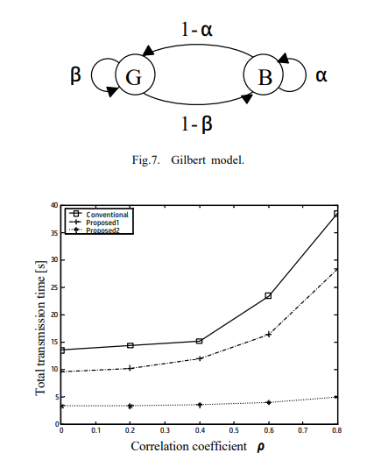

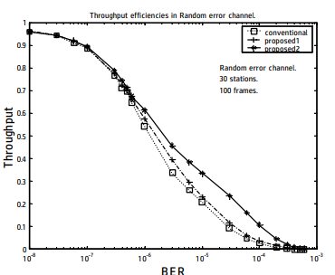

IV. .LITERATURE SURVEY

[1] In this paper, the multicast method which shortens the total transmission time and enables efficient communications was proposed. Many of conventional methods have adopted random time. After all receivers wait during random time, they return NACK. However, the collision probability of feedback is not 0 though it is low . Reliable Multicast (RM) is a mechanism that makes the multicast reliable, and a lot of Reliable Multicast Protocol has been proposed. This is the protocol to transmit copies of the same data to receivers correctly (error-free), and it offers high reliability for each data frame with error control scheme .RM protocols are classified into ACK-based scheme and NACK-based scheme. The ACK-based protocols offer high reliability, because the sender confirms if the correct frames transmitted to all receivers. However, if ACK is transmitted at a comparatively short cycle, ACK implosion will happen easily. Reliability ,where needed, would be accomplished by a transport layer protocol . The choice of whether to use the connectionless connection-oriented service in a particular case would be based largely on economic criteria . Connectionless and non-reliable connection oriented. On the other hand, the NACK-based protocol offers the scalability, although, the reliability of the multicast data frame is not guaranteed when NACK is lost. An RM protocol based combination of ACK-based and NACK-based is proposed and this method has both scalability and high reliability. However, it is necessary to perform carrier sense, and to prevent overlapping NACK for the same frame, it is also necessary to wait during random time because this protocol employs the NACK-based. Moreover, there is still possibility to happen the collision of the NACK even after random time. It is assumed that all receivers have the same BER. Throughput is the most important index for the performance evaluation of the system. The receiver, which can return responses for the reception frames, is limited to one. Therefore, the NACK repetition for the same frame can be prevented and the number of responses is decreased. Moreover, because it is not necessary to wait during random time to evade the collision of the responses, wasted time is reduced. Because the throughput performance does not depend on the numbers of receivers, it is possible to apply to a large-scale multicast group. Moreover, it offers a steady performance also for the burst-error channel.

1. CONCLUSION

In this paper, the multicast method which shortens the total transmission time and enables efficient communications was proposed. Many of conventional methods have adopted random time. After all receivers wait during random time, they return NACK. However, the collision probability of feedback is not 0 though it is low. In proposed method, there is the only receiver which can request retransmission for the failure frames reception, and other receivers do not request even retransmission for the failure frames reception. There is no problem of the collision, and therefore it is not necessary to wait during random time. The transmissions of the all multicast frames in a short time are enabled. Because the throughput performance does not depend on the numbers of receivers, it is possible to apply to a large-scale multicast group. Moreover, it offers a steady performance also for the burst-error channel.

In this paper, the capacity of the reception buffer has been assumed to be infinity. It is necessary to consider the limited reception buffer. Each path from the source host to each receiver has been assumed to be independent, but it is possible that there is a correlation between each path. We should work with these problems in the future

VI. REFERENCES

[1] M. Pompili, S. L. N. Hermans, S. Baier, et al.,Realization of a multinode quantum network of remote solid-state qubits,Science 372, 259 (2021).

[2] T. Y. Chen, X. Jiang, S. B. Tang, et al., Implementation of a 46-node quantum metropolitan area network, npj Quantum Inf.7, 134 (2021)

.

[3] M. Pompili, C. D. Donne, I. Raa, et al., Experimental demonstration of entanglement delivery using a quantumnetwork stack, arXiv:2111.11332 (2021).

[4] J. Illiano, M. Caleffi, A. Manzalini and A. S Cacciapuoti,Quantum internet protocol stack: a comprehensive survey,arXiv:2202.10894v1, (2022).